Lahore Garrison University
DHA Phase 6 Lahore



Student Name | Shahzaib Ahmad
Student Roll No | Fa-2023-BSCS-703
Section | D
Subject | Web Technology
Instructor Name | Sir Muhammad Yousaf

Lab Task No. 06

Lab 6: CSS Fundamentals & Box Model:

Lab Objectives
- Apply CSS rules to style a webpage.
- Understand and use the CSS Box Model.
- Use selectors, positioning, and layout techniques.
- Inspect and debug layout using browser DevTools.

Tools Required
- VS Code (with Live Server extension)
- Browser DevTools (Chrome, Firefox, etc.)
- A basic HTML portfolio page to style

Step-by-Step Tasks

🔹 Step 1: Style the Personal Portfolio

📄 HTML File (index.html) – Basic Structure
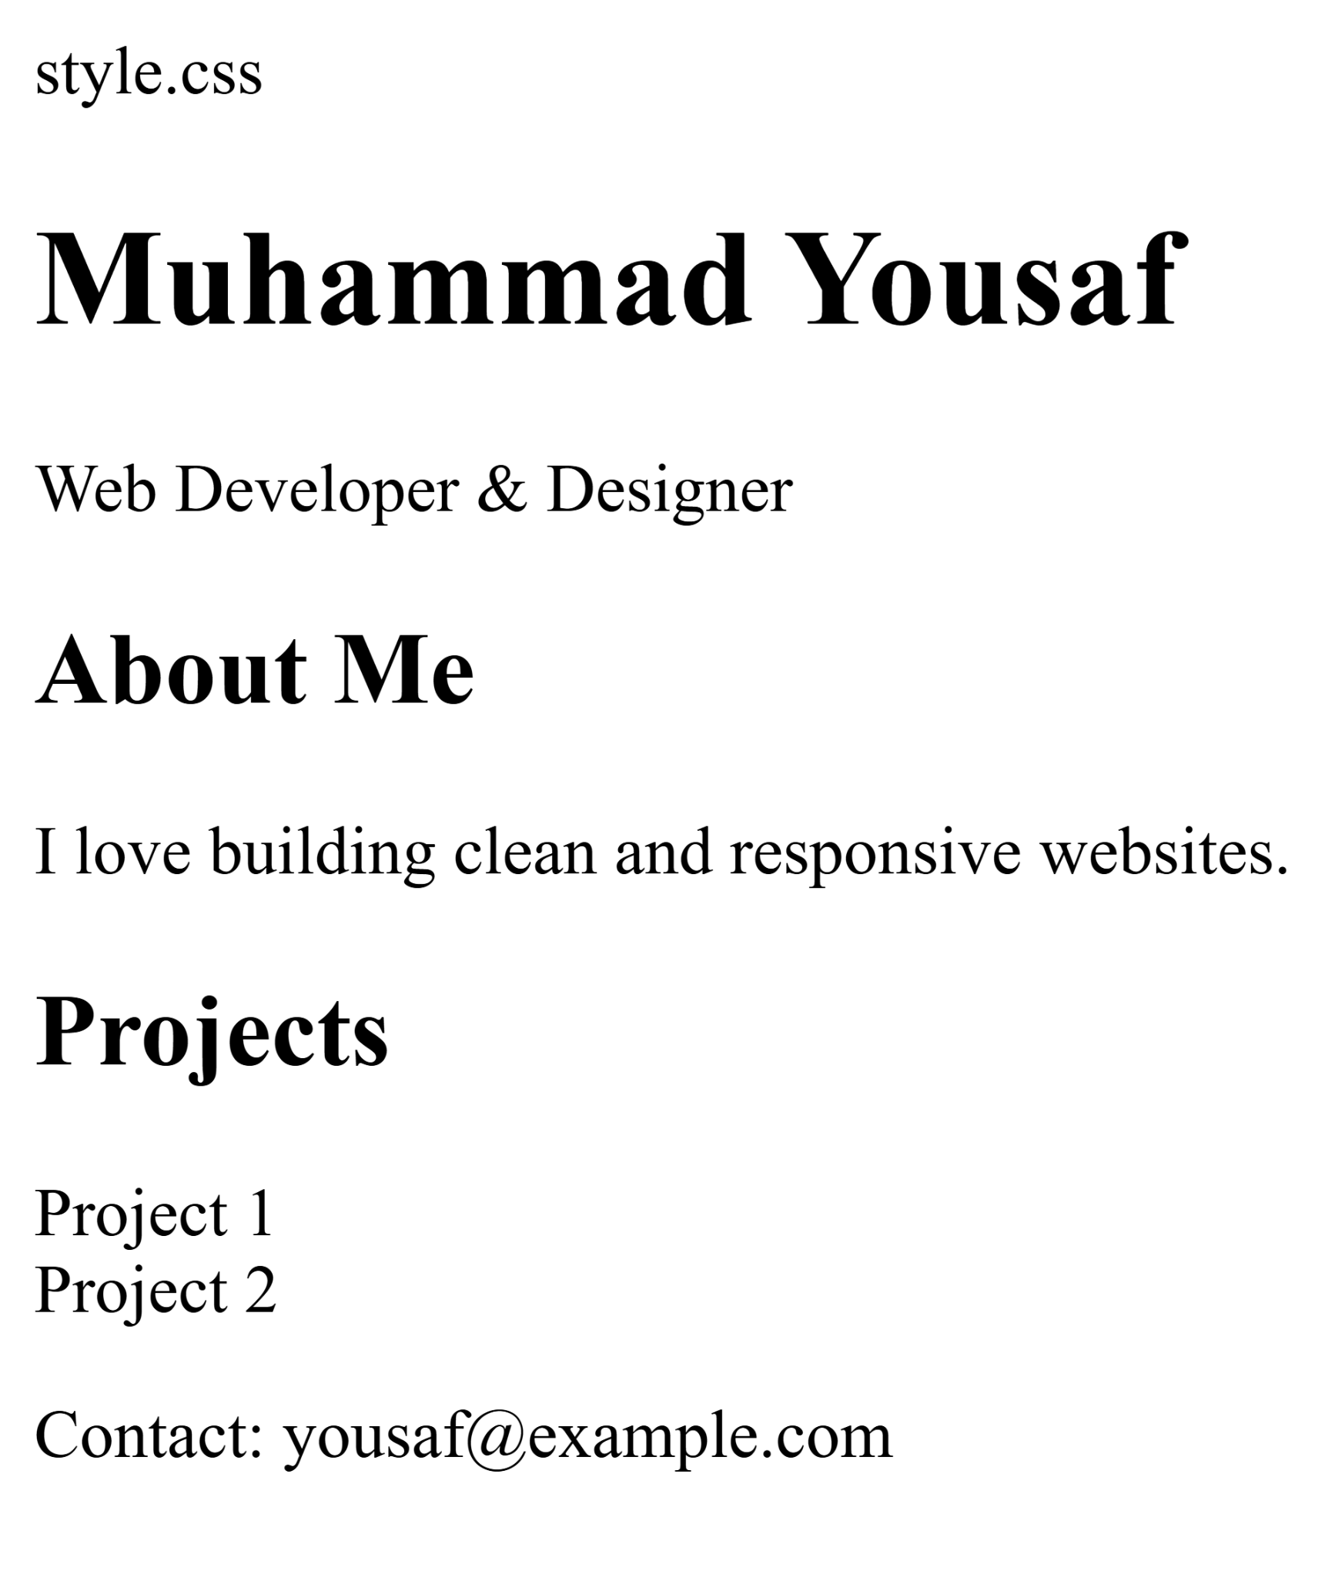

CSS File (style.css) – Styling and Box Model
/* General Reset /
{
box-sizing: border-box;
margin: 0;
padding: 0;
}

/* Body Styling /
body {
font-family: Arial, sans-serif;
background-color: #f4f4f4;
color: #333;
padding: 20px;
}

/ Header /
header {
background-color: #007acc;
color: white;
padding: 20px;
margin-bottom: 20px;
border-radius: 8px;
}

/ Class and ID Selectors /
#main-title {
font-size: 2em;
}

.tagline {
font-style: italic;
}

/ Section Styling /
.about, .projects {
margin-bottom: 20px;
padding: 15px;
background-color: white;
border: 1px solid #ccc;
border-radius: 5px;
}

/ Project Cards with Float /
.project-card {
float: left;
width: 45%;
margin: 2.5%;
padding: 10px;
background-color: #e0e0e0;
border: 1px solid #999;
border-radius: 5px;
}

/ Clearfix /
.projects::after {
content: "";
display: table;
clear: both;
}

/ Footer */
footer {
text-align: center;
padding: 10px;
background-color: #ddd;
border-radius: 5px;
}

🔹 Step 2: Use Selectors and Layout Techniques
- ID Selector: #main-title
- Class Selector: .tagline, .project-card
- Descendant Selector: section .project-card
- Float and Clear: Used for .project-card and .projects::after
- Modern Alternative: You can replace float with Flexbox or Grid for responsive layouts.

🔹 Step 3: Use DevTools to Inspect Box Model

📘 How to Inspect:
- Open the page in a browser.
- Right-click on any element (e.g., .project-card) and choose Inspect.
- In the Elements tab, look at the Box Model section:
  - Check margin, border, padding, and content.
  - Adjust styles live to fix layout issues.
Deliverable: Take screenshots of the DevTools showing the box model for at least one element.
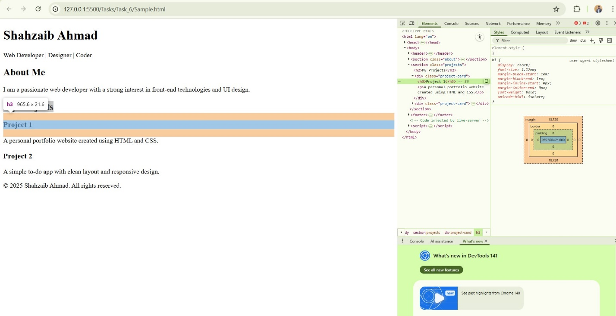

Final Deliverables
- index.html – Portfolio page
- style.css – CSS file with styling and layout
- Screenshots of DevTools showing box model inspection

CONCLUSION:
In this lab, I learned how to use CSS to style web pages and control their layout. I explored different types of selectors like class, ID, and descendant selectors. I also understood the concept of the CSS Box Model and how margin, border, padding, and content affect element spacing. Using browser DevTools helped me visualize and adjust these properties easily. Overall, this lab improved my skills in webpage styling and layout design using CSS.

RUBRICS:

Performance |  |  | Lab Report
Description | Total Marks | Marks Obtained | Description | Total Marks | Marks  Obtained
Ability to Conduct practical | 5 |  | Structure | 5
Data Analysis & Interpretation | 5 |  | Efficiency | 5
Total Marks obtained |  |  | Total Marks Obtained

Instructor Signature

